1. Differentiate between SIMD and MIMD? Explain

* MIMD stands for Multiple Instruction Multiple Data. In the SIMD design, an instruction is applied to a particular set of information or data at a constant time. SIMD stands for Single Instruction Multiple Data. While MIMD stands for Multiple Instruction Multiple Data. The SIMD architecture simultaneously performs an identical action on multiple pieces of data, including information retrieval, computation, or storage. An example is recovering multiple files at once. Processors with local memory that hold different data execute the same instruction in a synchronous manner, with inter-processor communication to assign offsets. The MIMD architecture performs several concurrent actions on multiple data sets. One example is performing different mathematical operations - such as addition and multiplication - simultaneously to solve a complex math problem with many discrete components. MIMD computing may or may not be synchronized and is becoming more common than SIMD computing. SIMD is often used for computationally intensive problems with processors performing the same operation in parallel. MIMD is often used for problems that break down algorithms into separate, independent parts, with each part assigned to a different processor for a concurrent solution.

1. What are the performance metrics of parallel systems?

There are four performance metrics of parallel systems the first one is execution time. Parallel runtime is the time that elapses from the moment a parallel computation starts to the moment that processing element finished execution. And the second one is total parallel overhead. Total time collectively spent by the processing elements – running time required by the fastest known sequential algorithm fir solving the same problem on a single processing element. The third one is speed up is the ration of the serial runtime of the best sequential algorithm for solving a problem to the time taken by the parallel algorithm to solve the same problem on p processing elements. And the last one is efficiency, Efficiency is a ration of speedup pto the number processing element.

1. What is pipelining

* Pipelining is the process of accumulating instruction from the processor through a pipeline. It allows storing and executing instructions in an orderly process. It is also known as pipeline processing. Pipelining is a technique where multiple instructions are overlapped during execution. Pipeline is divided into stages and these stages are connected with one another to form a pipe like structure. Instructions enter from one end and exit from another end. Pipelining increases the overall instruction throughput. Pipelining defines the temporal overlapping of processing. Pipelines are emptiness greater than assembly lines in computing that can be used either for instruction processing or, in a more general method, for executing any complex operations. It can be used efficiently only for a sequence of the same task, much similar to assembly lines.

1. Illustrate and explain what a von Neuman architecture

* The von Neumann architecture the fundamental architecture upon which nearly all digital computers have been based has a number of characteristics that have had an immense impact on the most popular [programming languages](https://www.sciencedirect.com/topics/computer-science/programming-language). These characteristics include a single, centralized control, housed in the [central processing unit](https://www.sciencedirect.com/topics/computer-science/central-processing-unit), and a separate storage area, primary memory, which can contain both instructions and data. The instructions are executed by the CPU, and so they must be brought into the CPU from the primary memory. The CPU also houses the unit that performs operations on operands, the arithmetic and logic unit (ALU), and so data must be fetched from primary memory and brought into the CPU in order to be acted upon. The primary memory has a built-in addressing mechanism, so that the CPU can refer to the addresses of instructions and operands. Finally, the CPU contains a register bank that constitutes a kind of “scratch pad” where intermediate results can be stored and consulted with greater speed than could primary memory.

Level 2

1. how does the parallel programming works

Programming can be differentiated with larger or smaller problems. As with parallel programming, this process breakdowns larger problems into smaller problems. Multiple processors are working simultaneously that communicates with a shared memory. As per the results, they are being combined after all the process as the overall. The parallel approach takes a high rate of advantage. It conserves time and effort because of many resources that are working simultaneously. It is not just effective but it is also efficient for it process a large problem faster than we could ever imagine.

1. **In a right triangle, the square of the length of one side is equal to the sum of the squares of the lengths of the other two sides. Write a program that prompts the user to enter the length of the three sides of a triangle and then outputs a message indicating whether the triangle is a right triangle. The advantage of parallel computing is that due to the time savings provided by parallel computing, applications can now be run in less wall-clock time. Due to the size and/or complexity of many problems, solving them on a single ssthat computers have available in here with this, the parallel computing is the best approach.**

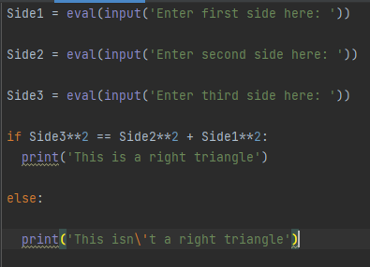 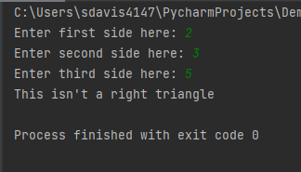

1. Write a program that prompts the user to input a number between 0 and 35. If the number is less than or equal to 9, the program should output the number; otherwise, it should output A for 10, B for 11, C for 12… and Z for 35.

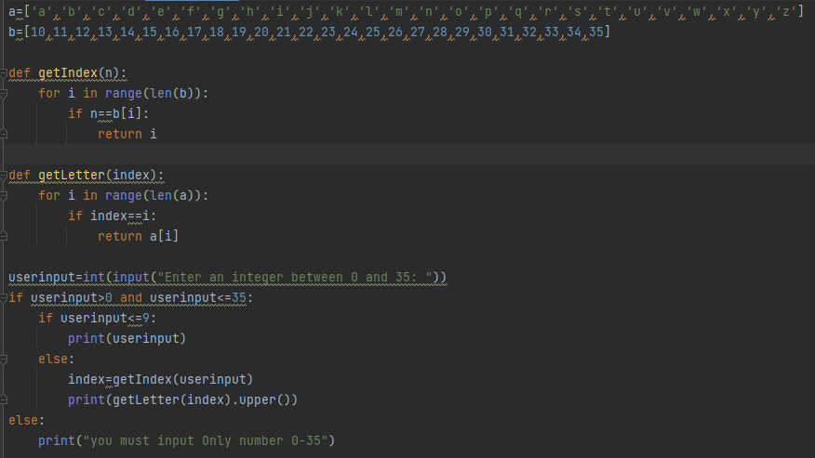

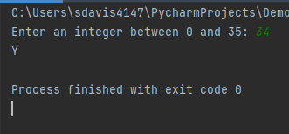

1. Write a program that will display all numbers divisible by 3, 4 and 5 from 1-50

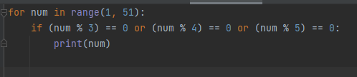

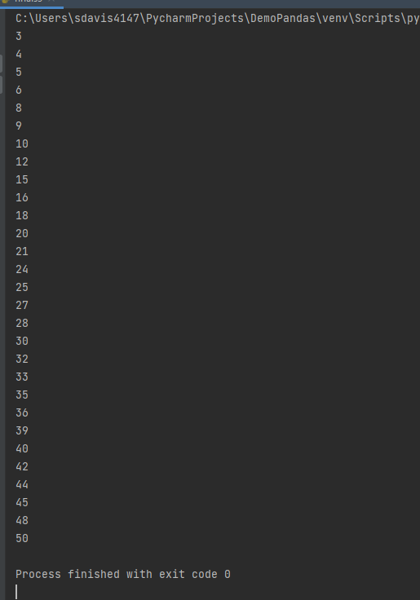

Level 3.

1.

2.

1. Create a function in Python that accepts two parameters. The first will be a list of numbers. The second parameter will be a string that can be one of the following values: asc, desc, and none. If the second parameter is "asc," then the function should return a list with the numbers in ascending order. If it's "desc," then the list should be in descending order, and if it's "none," it should return the original list unaltered.

